ASSIGNMENT NO-8

Q-1) Assume each salesperson has a 12% commission. Write a query on the orders table that will produce the order number, the salesperson number, and the amount of the salesperson’s commission for that order.



Q-2) Write a query on the customers table that will find the highest rating in each city. Put the output in this form

For the city (City), the highest rating is : (rating)

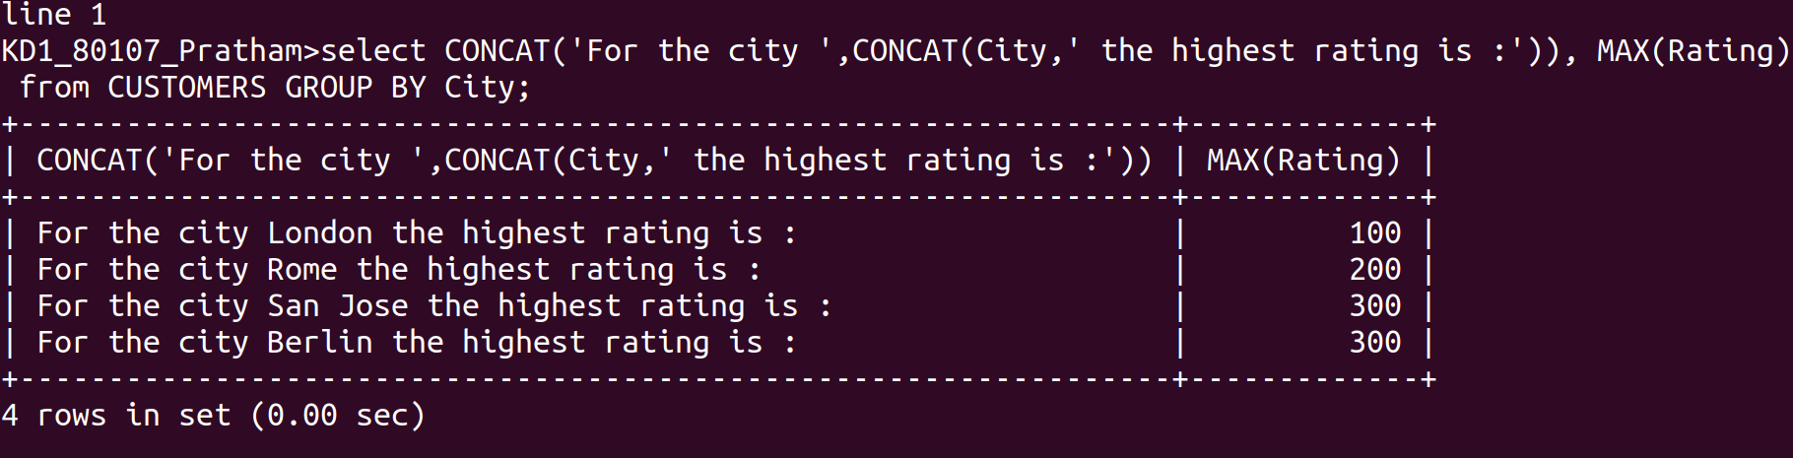

Q-3) Write a query that lists customers in descending order of rating. Output the rating field first, followed by the custormer’s name and number.

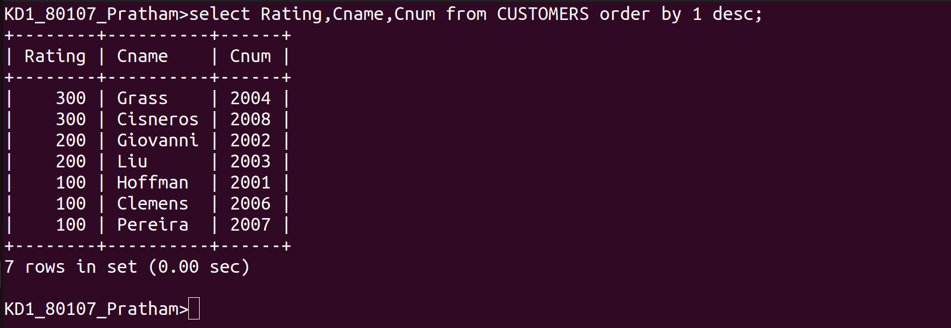

Q-4) Write a query that totals the orders for each day and places the results in descending order.
